MS Teams Acumatica Business Event Extension

Installation:

1. Configure MS Teams Incoming Webhook
   1. Click on More options (…) from Team Channel
   2. Click on Connectors 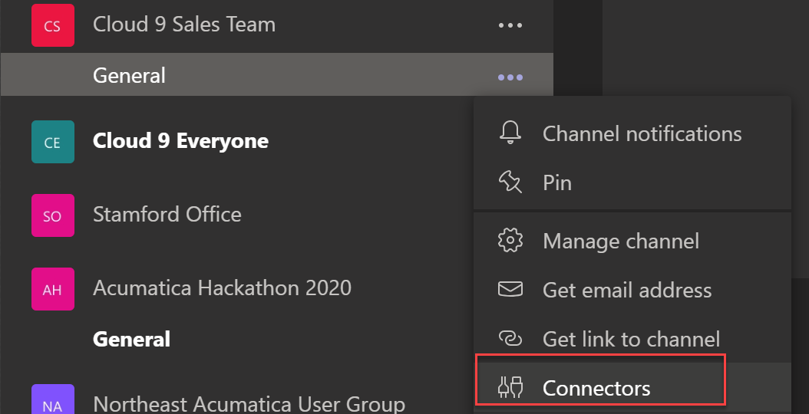
   3. Click/search on Incoming Webhook
   4. Click Add
   5. Provide Unique Name
   6. Upload Image Optional
2. Click Create 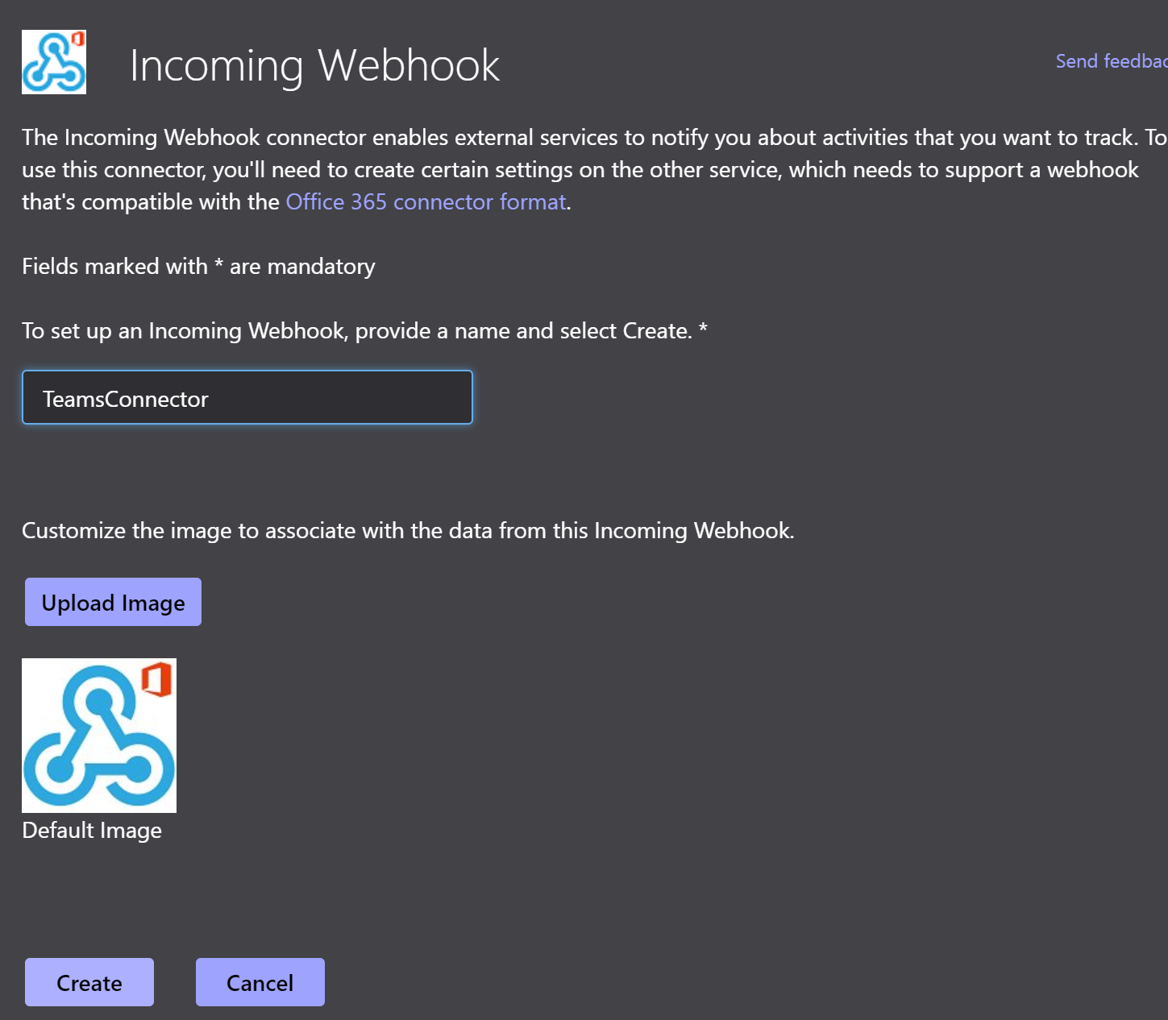
   1. A URL is created, Copy to Clipboard
   2. Save Name and URL 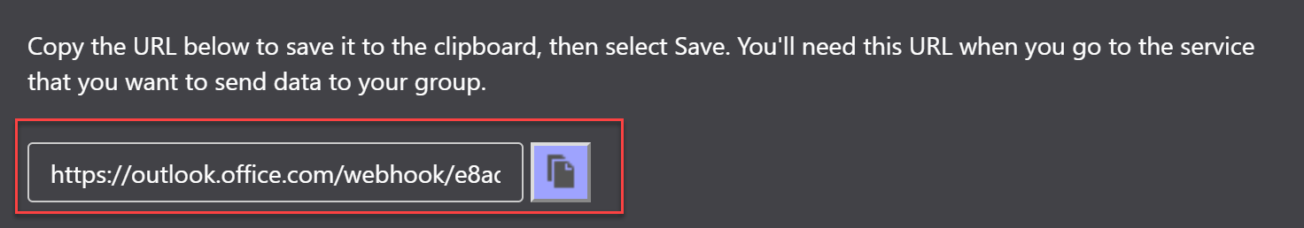
3. Go to Acumatica
4. Upload Customization Package MSTeamsIntegration.Zip
5. Publish
6. Search for Screen Microsoft Teams Channel
7. Create New Microsoft Teams Profile
8. Add Name
9. Populate Incoming Webhook Name and URL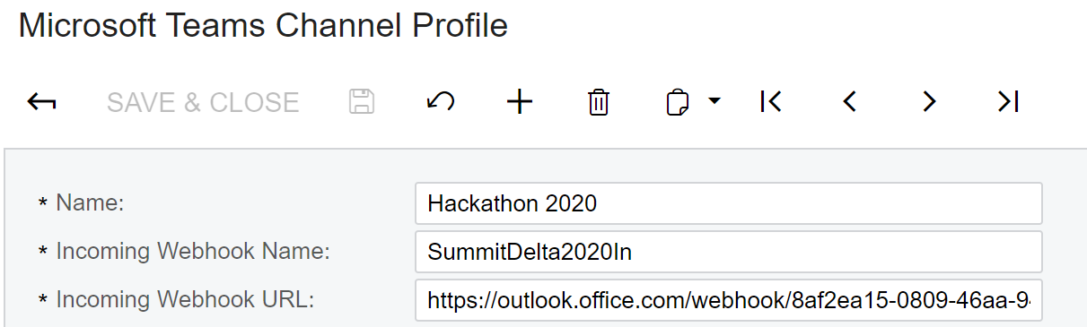
10. Save
11. Go to Business Events
12. Create your Business Events
13. Subscriber, Create New SMS Subscriber
14. Change Delivery Method to Teams
15. Under To, Select Your Teams Channel Profile you Created in step 6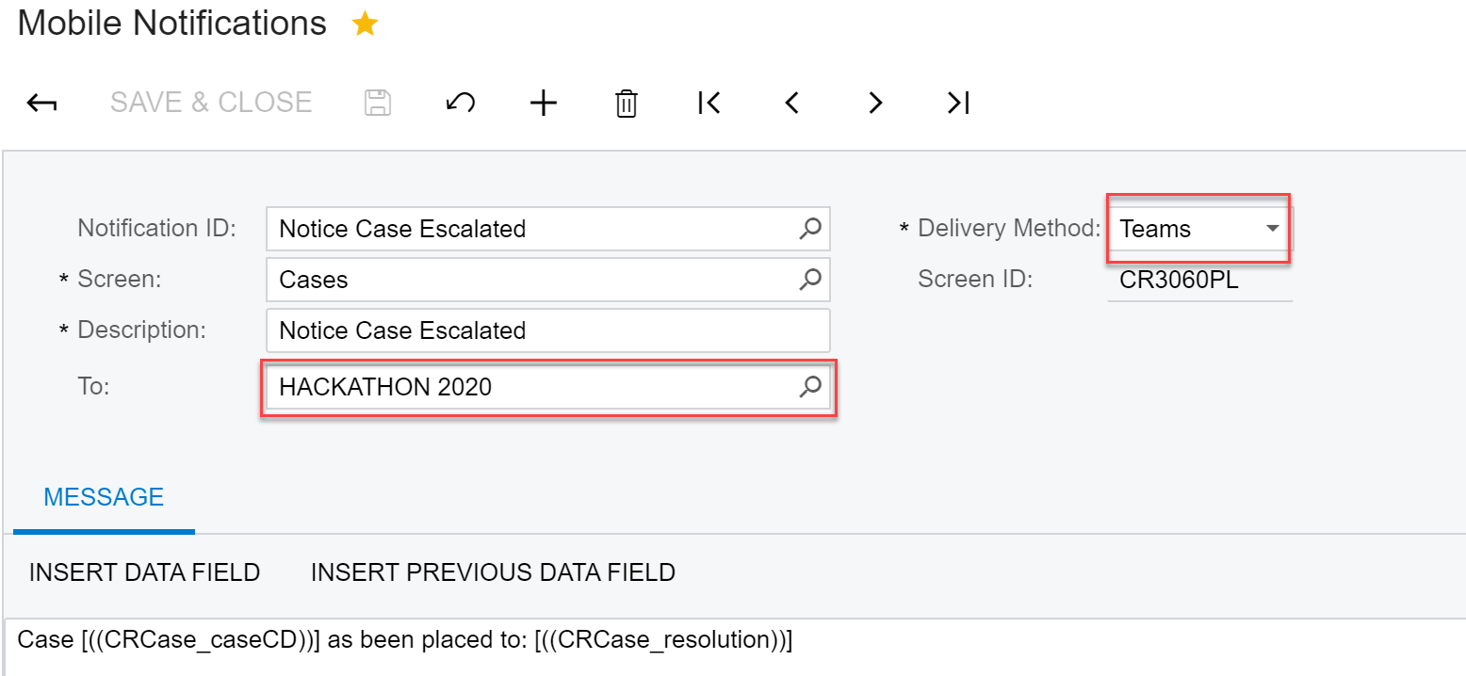
16. Complete your Notification Template